**Course :** Digital Image Processing

**Name :** Md. Fahim Shahriar

**Student ID :** 154440

**Lab Assignment 1**

**Task 1:** Display the histogram and negative transformation of a Gray scale Image.

**Code:**

A = imread('illusion.png');

A = rgb2gray(A);

[n m] = size(A);

freq = zeros(256);

for i = 1 : n

for j = 1 : m

freq(A(i,j) + 1) = freq(A(i,j) + 1) + 1;

end

end

plot(freq);

imhist(A);

imgout = zeros(n,m,'uint8');

for i = 1 : n

for j = 1 : m

imgout(i,j) = 255 - A(i,j);

end

end

imtool(A);

imtool(imgout);

**Output:**

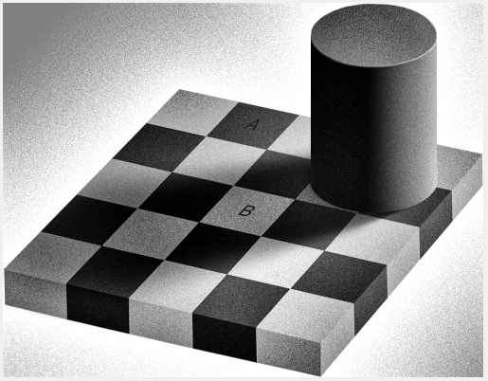

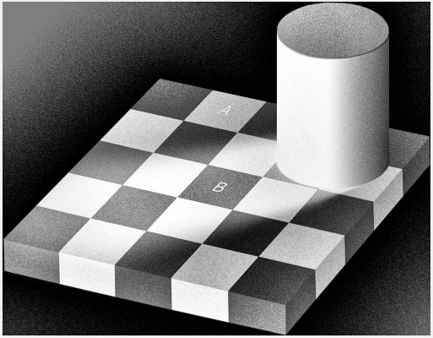

Figure 1 : Negative Transformation of Grayscale Image

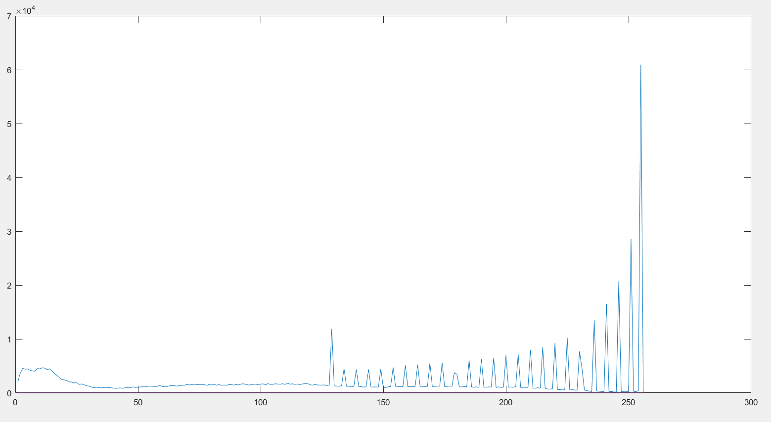

Figure 2: Histogram Displaying the intensity of Grayscale Image

**Discussion:** A grayscale image has a single channel. All its intensity value ranges from **0** to **255.** When we invert an intensity $F(x,y)$, it becomes $F`(x,y) = 255 – F(x,y)$.

Thus the black part becomes white and white parts becomes black.

From the histogram we can see that, it has so many spikes. It occurred deut to the lighting effect in the image.

**Task 2:** Display RGB Channel individually for a Color Image

**Code:**

A = imread('yay.jpg');

[n m] = size(A);

subplot(1,4,1);

imshow(255-A(:,:,1));

subplot(1,4,2);

imshow( 255-A(:,:,2));

subplot(1,4,3);

imshow( 255-A(:,:,3));

subplot(1,4,4);

imshow(A);

**Output:**

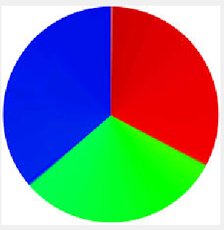

Figure 3: Original Image

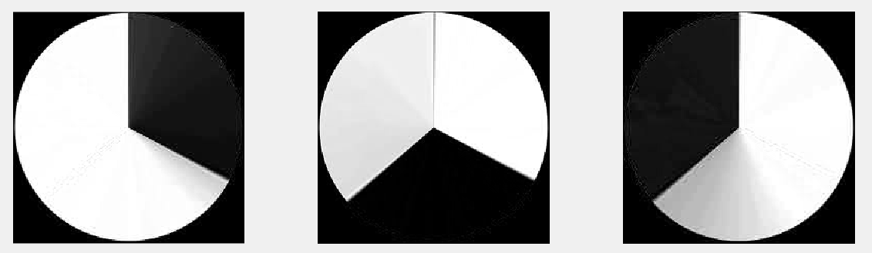

Figure 4: **Red Channel , Green Channel** and **Blue Channel**

**Discuusion**: Color image has $2^{24}$ different color formats. The distribution of color is divided into 3 different channels which are Reg, Green and Blue. Each channel may contain $256$ different intensity values. If we separate these channel and create a single channel image, we will get these type of images shown in Figure 4.

**Task 3:** Display Red, Green , Blue Color Individually in an image containing 3 channels

**Code:**

imgin = imread(yay.jpg');

[R,C,P] = size(imgin);

imgout = zeros(R,C,'uint8');

onlyred = imgin;

onlyred(:,:,2) = 0;

onlyred(:,:,3) = 0;

imtool(onlyred);

onlygreen = imgin;

onlygreen(:,:,1) = 0;

onlygreen(:,:,3) = 0;

imtool(onlygreen);

onlyblue = imgin;

onlyblue(:,:,1) = 0;

onlyblue(:,:,2) = 0;

imtool(onlyblue);

**Output:**

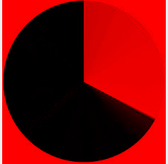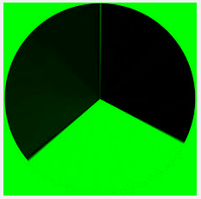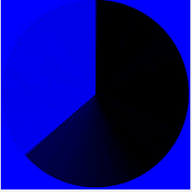

Figure 5: Red Channel Green Channel Blue Channel

**Discuusion**: The channels are displaying red, green and blue color since they are mapped in three channels but only 1 of the channel is made to have a color while the other two channels are emptied. Therefore by keeping the red channel activated it is only showing the red color, by having the green channel activated it is only showing the green channel and lastly by having the blue channel only activated it is only showing the blue channel